# Installing Quire

This page on the Getty’s website for Quire will guide you through the installation process: <https://quire.getty.edu/docs-v1/install-uninstall/>. The page includes instructions for both macOS and Windows users.

There is a tendency for this process to be easier for mac users. The most common problem encountered by mac users involves permissions, and can usually be solved by following the troubleshooting guidance here: <https://quire.getty.edu/docs-v1/troubleshooting/#installing-quire-on-macos>

The problems that may be encountered by Windows users are more diverse and less predictable. If you are on Windows and you experience problems, first try your best to solve the problem by reading the errors you are getting in the console and following any instructions that are provided.

**Do not worry if you are unable to fix the problem and install Quire.** We will be offering to help anyone having installation issues during lunchtime on Wednesday. We also intend to put participants into groups for the exercise on Thursday, ensuring that at least one member in each group has successfully installed Quire.

# Adding the Linked Art in Quire extension

We will provide a zip file called ‘la_quire_extension.zip’ on the DHOxSS Canvas page for our session. It contains files that need to be added to the Quire installation in order for the software extension developed at Oxford to be used. Download the file, extract the contents, and follow these steps to add them to the installation:

1. Find the command line interface (CLI) of the Quire installation on your system. It is a folder called ‘quire-cli’.
   1. **macOS:**

Locate the Quire symlink

* + - * Open Terminal
      * Run the command ‘which quire’
      * This will output the path to the Quire symlink. For example, the output might look something like ‘/Users/<YourUsername>/.nvm/versions/node/v20.14.0/bin/quire’

Find the target of the symlink

* + - * Run the command readlink -f followed by the output of the previous command, e.g. ‘readlink -f /Users/<YourUsername>/.nvm/versions/node/v20.14.0/bin/quire’
      * The output will show the full path of what the symlink points to. For example, it might look like this: ‘/Users/<YourUsername>/.nvm/versions/node/v20.14.0/lib/node_modules/@thegetty/quire-cli/bin/cli.js’

Follow the path to quire-cli and open it in Finder

* + - * Follow the path you received as output in the last step up to quire-cli.
        + Note: This means excluding the last part of the path ‘/bin/cli.js’
      * In our example, the final path to the quire-cli folder looks like this: ‘/Users/<YourUsername>/.nvm/versions/node/v20.14.0/lib/node_modules/@thegetty/quire-cli’
      * Follow the path by using the cd command, e.g.: ‘cd /Users/<YourUsername>/.nvm/versions/node/v20.14.0/lib/node_modules/@thegetty/quire-cli’
      * After navigating to the folder, you can open it in Finder by running the command ‘open .’

This is what the whole process looks like for our example in the terminal:

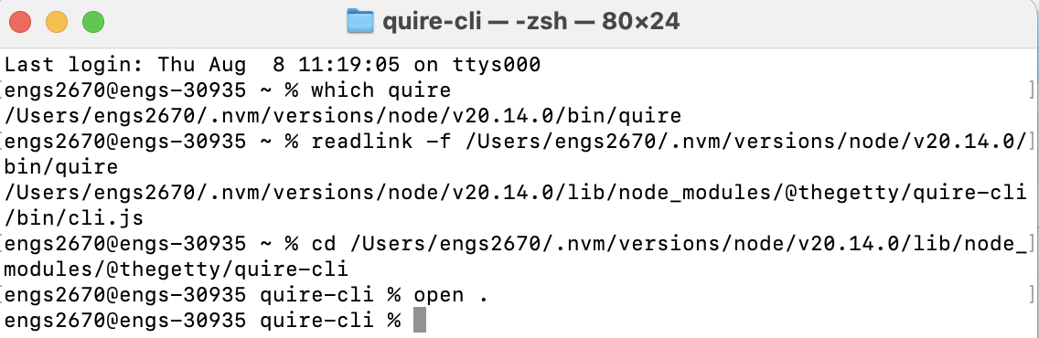

* 1. **Windows:**

Locate the Quire Executable

* + - * Open powershell
      * Run the command ‘where quire’
      * This will output the path to the Quire executable. The output might look something like ‘C:\Users\<YourUsername>\AppData\Roaming\npm\quire’

Find the Target of the Executable

* + - * Typically, on Windows, npm globally installs CLI tools in a directory under node_modules
      * Run the following command to locate the quire-cli installation folder: ‘dir /aL "C:\Users\<YourUsername>\AppData\Roaming\npm\quire"’
      * If this command shows that quire is a link, note the path it points to. It may look something like ‘C:\Users\<YourUsername>\AppData\Roaming\npm\node_modules\@thegetty\quire-cli\bin\cli.js’

Navigate to the quire-cli Folder

* + - * The quire-cli folder will be located in the node_modules directory of your global npm installation. If the previous command shows that quire points to a file like cli.js, you can determine the path to the quire-cli folder by truncating the path to end at quire-cli.
      * For example, if the path was ‘C:\Users\<YourUsername>\AppData\Roaming\npm\node_modules\@thegetty\quire-cli\bin\cli.js’, the quire-cli folder would be located at ‘C:\Users\<YourUsername>\AppData\Roaming\npm\node_modules\@thegetty\quire-cli’

Open the quire-cli Folder in File Explorer

* + - * To open the folder in File Explorer, you can directly navigate to it using the path from the previous step
      * Alternatively, you can use powershell to open it by running explorer ‘C:\Users\<YourUsername>\AppData\Roaming\npm\node_modules\@thegetty\quire-cli’

1. Find the ‘commands’ folder at the directory ‘quire-cli/src/commands’

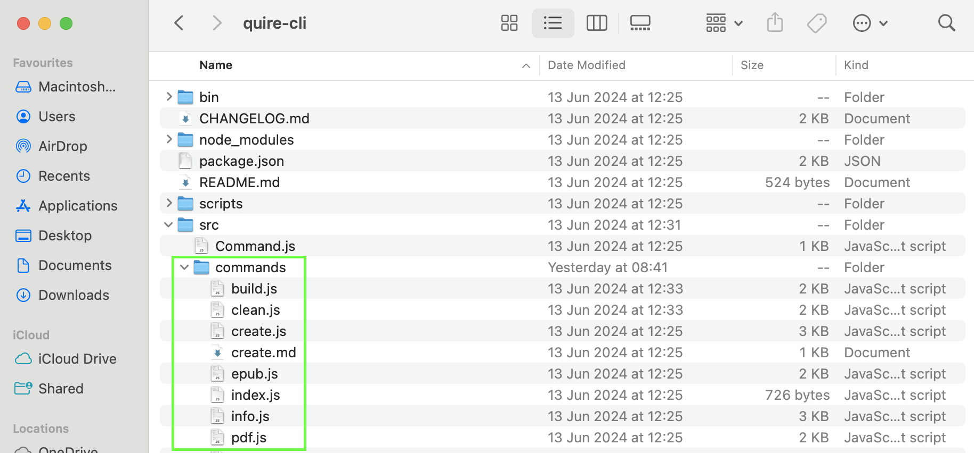

1. From the la_quire_extension folder, add the ‘yog-linked-art 0.7.js’ file to the commands folder
2. Replace the ‘build.js’ file in the commands folder with the ‘build.js’ file in the la_quire_extension folder
3. Replace the ‘clean.js’ file in the commands folder with the ‘clean (commands).js’ file in the la_quire_extension folder
4. Rename the ‘clean (commands).js’ file ‘clean.js’
5. Find the ‘helpers’ folder at the directory ‘quire-cli/src/helpers’

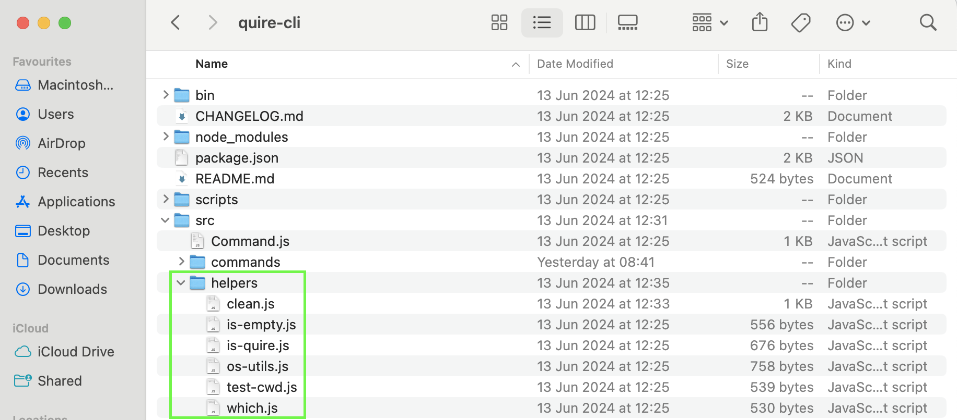

1. Replace the ‘clean.js file’ in the helpers folder with the ‘clean (helpers).js’ file in the la_quire_extension folder
2. Rename the ‘clean (helpers).js’ file ‘clean.js’

After following these steps, you should be able to run Quire with all its original functionality as well as the new functionality provided by the extension. If you have trouble adding the extension, do not worry. As explained above, we will do our best to help during lunchtime on Wednesday, and for the exercise on Thursday, we will ensure that at least one member in each group has successfully installed Quire.